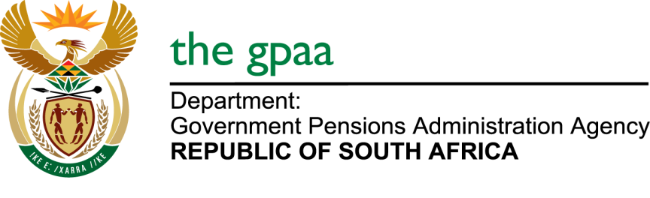

CLOSING DATE: 27 MAY 2019
SUPPLY, TRANSPORTATION, RIGGING, INSTALLATION, TESTING, COMMISIONING OF DIESEL GENERATORS CIDB GRADING 4EB/4ME (GPAA 11/2019)
NAME OF BIDDERS

- Mosomedi Refrigeration & Air Conditioning
- Leruwaruwa Trading and Projects
- Namasthethu Electrical
- Matase Industrial Solutions (Pty) Ltd
- Excellent Electrical Projects
- Buwesi Generator
- AMPCOR Khanyisa (Pty) Ltd
- Global Spec Group
- Lengwati Electrical
- DCI Projects

